Test plan for
PENTACKLES

ChangeLog

Version | Change Date | By | Description
001 | 1/11/2023 | Aakansha Tyagi , Aakriti Gupta , Ayush Jaiswal , Ayush Tyagi | Add Chatbot Model in System
002 | 3/11/2023 | Aakansha Tyagi , Aakriti Gupta | Finding test cases and increase stability

1 Introduction 2
1.1 Scope 2
1.1.1 In Scope 2
1.1.2 Out of Scope 2
1.2 Quality Objective 2
1.3 Roles and Responsibilities 3
2 Test Methodology 3
2.1 Overview 3
2.2 Test Levels 3
2.3 Test Completeness 4
3 Test Deliverables 5
4 Resource & Environment Needs 6
4.1 Testing Tools 6
4.2 Test Environment 6
5 Terms/Acronyms 6

Introduction
This website typically uses a sophisticated algorithm that analyzes various risk factors such as age, gender, medical history, lifestyle habits, and family history of heart disease. The primary objective of such a website is to raise awareness about heart disease and educate users on the risk factors associated with it. By providing users with a personalized risk assessment, the website can encourage individuals to take proactive measures to reduce their risk of heart disease, such as making lifestyle changes, seeking medical advice, and adopting healthy habits.

Scope

1.1.1 In Scope

Functional Requirements:

REQ-1: Patient Data Input: The system should allow for the input of relevant patient data, such as age, gender, family history of heart disease, medical history, lifestyle factors (e.g., smoking, alcohol consumption), and existing health conditions.
REQ-2: Risk Factor Assessment: Our system asses and analyze various risk factors for heart disease, such as high blood pressure, high cholesterol levels, obesity, sedentary lifestyle, smoking, diabetes, and other relevant factors, and calculate an overall risk score using established risk scoring models.

REQ-3: Diagnostic Test Integration: Our system is able to integrate with diagnostic test results, such as blood tests (e.g., lipid profile, glucose levels), electrocardiograms (ECGs), stress tests, or other relevant tests, to provide a more comprehensive assessment of the patient's cardiovascular health.

Non-functional requirements

1-The system must achieve a prediction accuracy rate of at least 80% for heart disease prediction.
2-The user interface should be intuitive and user-friendly to accommodate users of all technical backgrounds.

1.1.2 Out of Scope
The CVD prediction system does not cover forecasting of individuals below than 15 years or infants. It is focused solely on forecasting individuals between 16 to 90 year.

Quality Objective

- Ensure the Application Under Test conforms to functional and non-functional requirements.
- Ensure that the data set on which the model is trained contains all the necessary requirements.
- Validate that the dataset used for training the prediction model contains all the necessary dataset and parameters, ensuring the accuracy and comprehensiveness of the model.
- Bugs/issues are identified and fixed before going live.

.

Roles and Responsibilities

Test Manager: Prof. Harsh Vardhan
Managed all test processes, including test plans, resources, costs, timescales, test deliverables and traceability.

Configuration Manager: Prof. Akanksha

Developers: Ayush Tyagi, Ayush Jaiswal
Developed the model and trained it.

Installation Team: Aakansha Tyagi, Aakriti Gupta
Responsible for smooth execution of the program.

User Interface (UI) Team: Aakansha Tyagi, Aakriti Gupta
Responsible for ensuring a visually engaging website that enhances user experience and provides seamless access to predict result for CVD.

QA Analyst: Aakansha Tyagi, Aakriti Gupta, Ayush Tyagi, Ayush Jaiswal
The Quality Assurance (QA) Analyst conducted testing on software, websites, and other technical products to identify and resolve bugs, defects, and other potential issues.

Test Methodology

Overview
We have chosen the Waterfall test methodology for this project due to its structured and sequential approach. Waterfall's clear phase boundaries, early requirement specification, and risk mitigation capabilities are well-suited for the precision-focused nature for CVD prediction. This methodology ensures systematic progress and client involvement at key milestones.

2.2 Test Levels
2.2.1 Unit Testing
Objective: To test individual components and functions of the system to ensure they work as intended.
Test Cases:
- Test the data preprocessing functions to ensure accurate data transformation.
- Test the machine learning model to validate its prediction accuracy.
- Test input validation functions to handle different types of input data.
- Test output formatting and display functions.
2.2.2 Integration Testing
Objective: To test the integration of different components and modules to ensure they work together seamlessly.
Test Cases:
- Test the integration between data preprocessing and machine learning model.
- Test the integration between the prediction module and output formatting functions.
- Test the integration between user input validation and data processing.
2.2.3 System Testing
Objective: To test the entire system as a whole to ensure it meets the specified requirements.
Test Cases:
- Test the system's ability to handle different types of input data (numeric, categorical, missing values, etc.).
- Test the accuracy of predictions against a set of sample data with known outcomes.
- Test the system's performance under various load conditions.
- Test the system's error handling and recovery mechanisms.
- Test the system's security features to prevent unauthorized access or data breaches.

2.3Test Completeness

- 100% test coverage
- All Manual Test cases executed
- All open bugs are fixed or will be fixed in next release
- CVD is correctly predicted
- ML techniques are used with efficiency and predicted result with accuracy

Test Deliverables

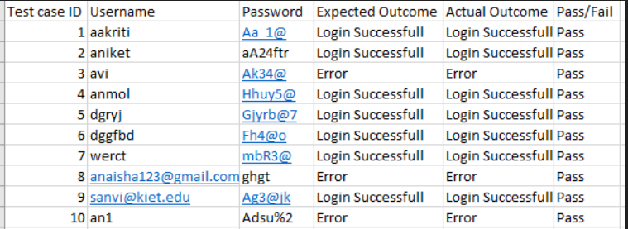

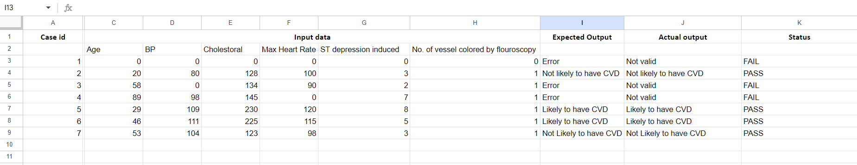

Resource & Environment Needs

Testing Tools

No Tools is used for testing because manual Testing is done

Test Environment

The following software’s are required in addition to client-specific software.

- Operating System: Windows 8 and above

- Development Environment: Google colab, numpy, Pandas, Seaborn, Matplotlib, VS Code (Visual Studio Code) for scripting and coding related to data analysis for predicting heart disease.

- Data Format: Ensure that the input data files are in the required format, such as CSV, Excel, or any other applicable format for predicting heart disease.

Terms/Acronyms
Terms used in the project are

TERM/ACRONYM | DEFINITION
CVD | Cardiovascular disease
HF | Heart Failure

